Nabeel Ahmed
D208 Task 2 Performance Assessment
04/26/2025

- Describe Purpose:
  - Can a customer’s tenure, monthly charges, and bandwidth usage be used to predict whether they will churn?
  - The goal of this analysis is to build a logistic regression model that predicts the likelihood of customer churn based on tenure, monthly charges, and bandwidth usage. The analysis aims to identify which factors have the strongest impact on customer churn and how they influence the probability of a customer leaving. These insights can help the organization develop better strategies to reduce churn and improve customer retention.
- Description of Logistic Regression Method:
  - Four Assumptions:
    - Linearity of Logit: The relationship between the independent variables and the log odds of the dependent variable must be linear.
(Assumptions of logistic regression)
    - Independence of Errors: Each observation must be independent from the others. (Assumptions of logistic regression)
    - No Multicollinearity: The independent variables should not be highly correlated with each other. (Assumptions of logistic regression)
    - Binary Dependent Variable: The dependent variable must be binary, meaning it has only two possible outcomes.
(Assumptions of logistic regression)
  - Two Benefits of Python
    - Efficiency and flexibility: Python has powerful libraries like pandas and
scikit-learn that make it fast and easy to clean data, build models, and
evaluate results.
    - Reproducibility and visualization: Python makes it simple to reuse code
for consistent results, and it provides strong visualization tools like
matplotlib and seaborn to display findings clearly.
  - Logistic regression is appropriate because the dependent variable, customer
churn, is binary. Logistic regression models the probability of an event occurring based on multiple predictors, which matches the goal of predicting whether a
customer will churn.
- Data Preparation Process:
  - Data Cleaning Goals
The goal of data cleaning was to prepare the dataset for logistic regression by
ensuring that all relevant variables were complete, numeric, and correctly
formatted. The cleaning process focused on handling missing data, removing
irrelevant columns, verifying the dependent variable format, and eliminating
duplicates.
    - Dropped unrelated columns that were not necessary for the research
question.
    - Filled missing values in Income, Tenure, and Bandwidth_GB_Year using either the mean or median depending on the distribution.
    - Converted the dependent variable Churn from "Yes"/"No" to 1/0 for
modeling.
    - Confirmed that all variables used were numeric
    - Dropped any duplicate rows from the dataset.
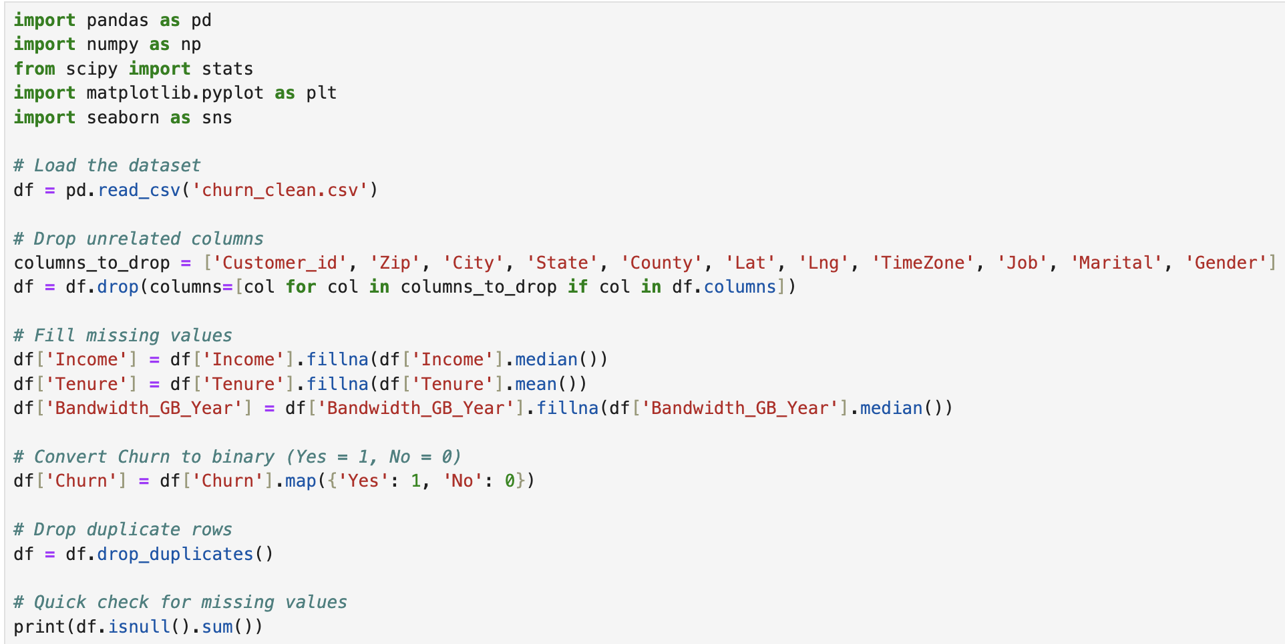
    - Checked for missing values.
  - The summary statistics help describe the key characteristics of the dependent and independent variables. The Churn variable is binary, with a mean of around 0.26, meaning approximately 26% of customers in the dataset churned. Tenure has a
mean of about 34.5 months, with a minimum tenure close to 1 month and a
maximum of 72 months, showing a wide range of customer loyalty lengths.
MonthlyCharge averages around $172.62, ranging from about $80 to $290,
indicating varying service levels and billing amounts. Bandwidth_GB_Year has a mean of about 3,392 GB per year, with usage ranging from as low as 155 GB to over 7,100 GB.
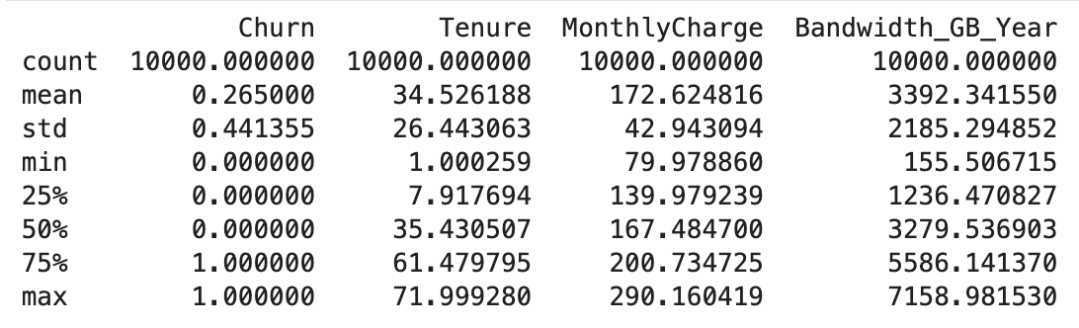
  - Univariate and Bivariate Visualizations:
Univariate visualizations were created to display the distributions of Tenure,
MonthlyCharge, Bandwidth_GB_Year, and Churn. Bivariate visualizations were generated to examine the relationships between MonthlyCharge and churn status, and between Tenure and Bandwidth_GB_Year colored by churn outcome.
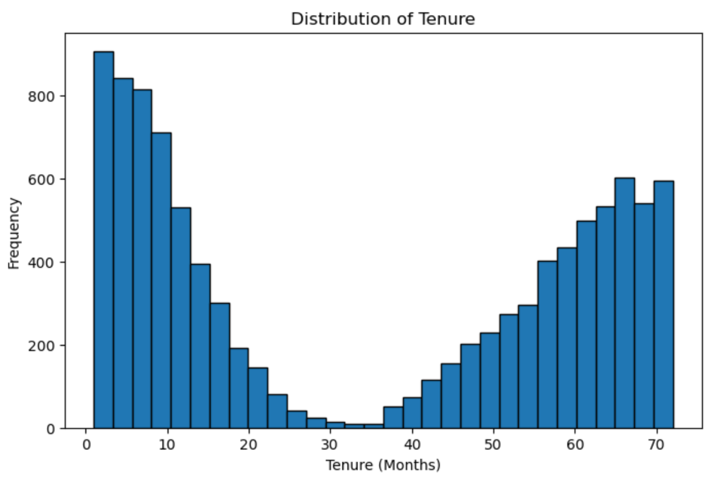
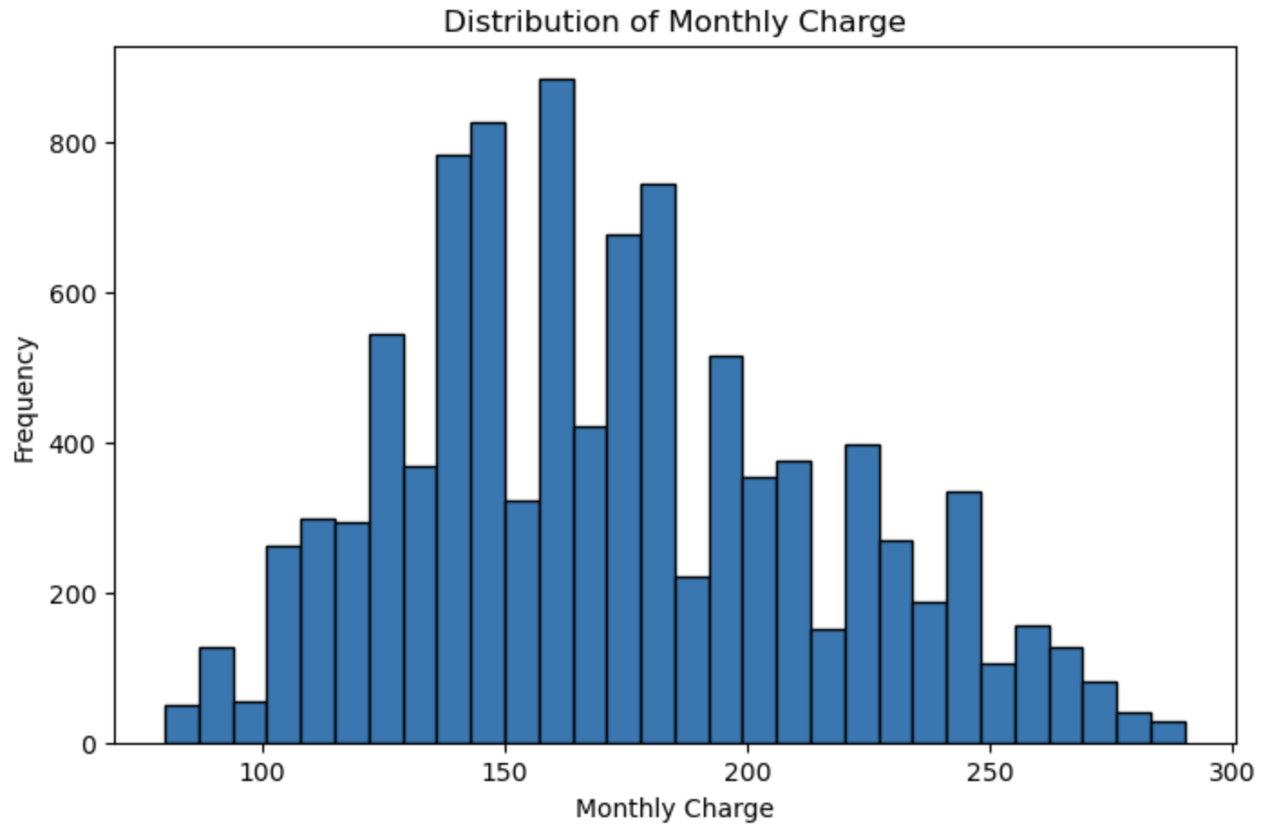
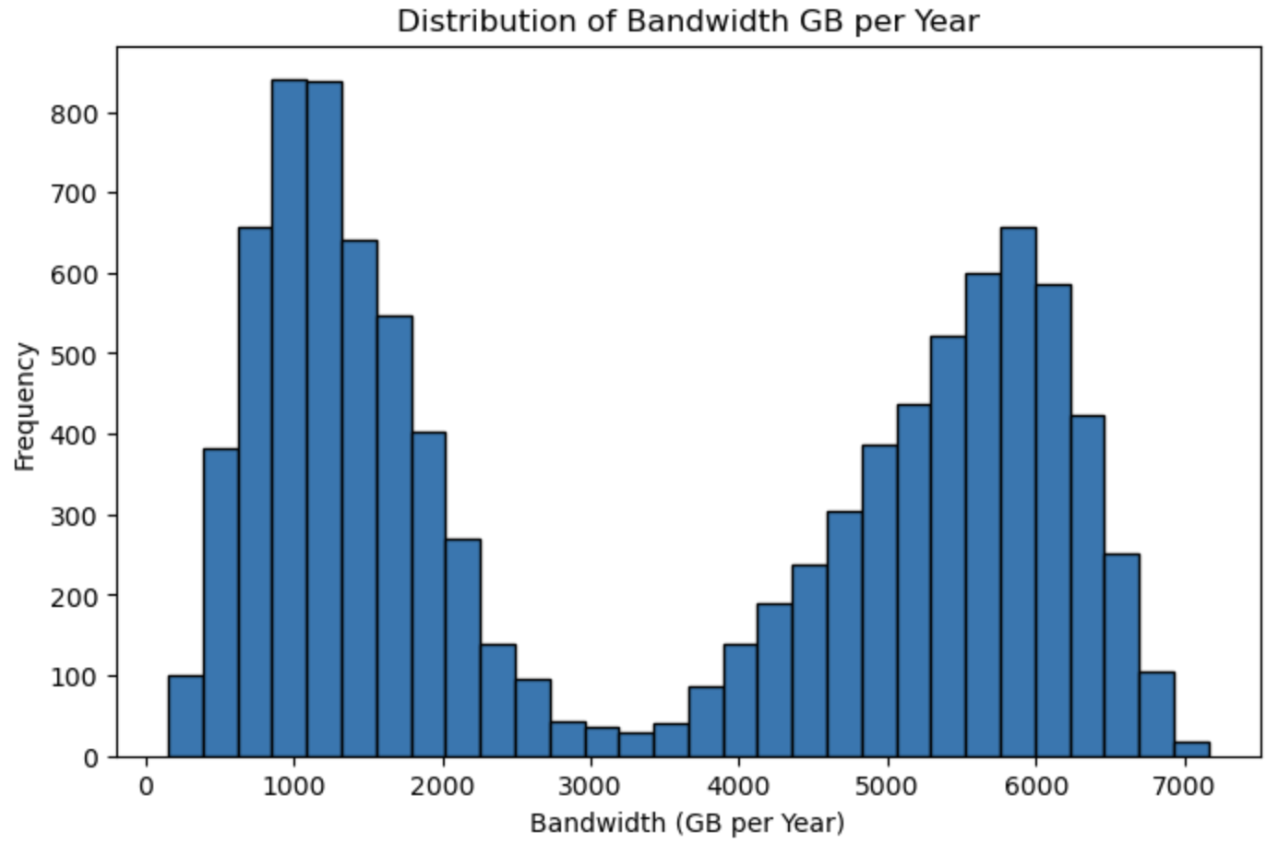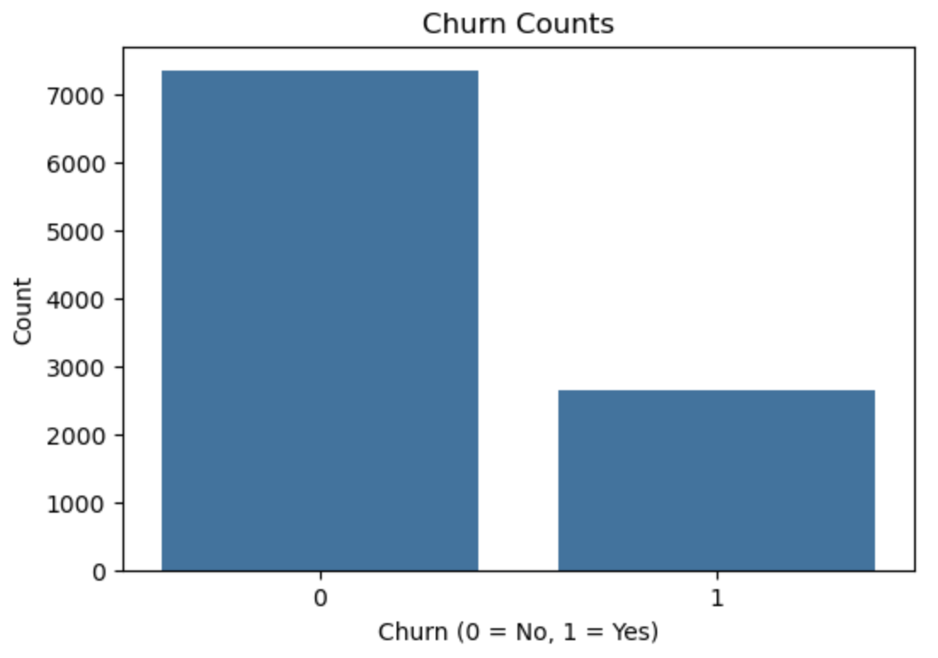
Bivariate Visualizations with Dependent Variable
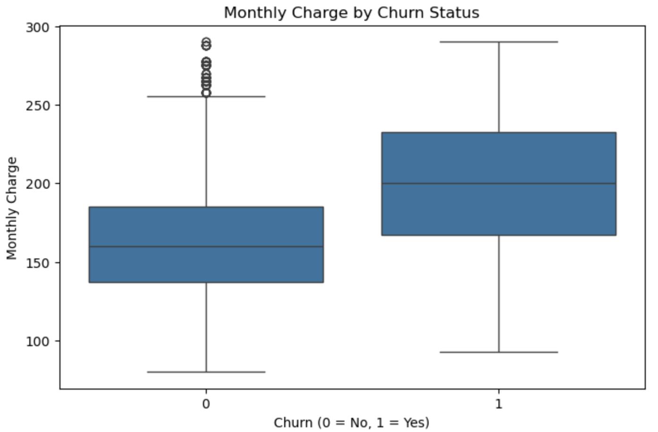
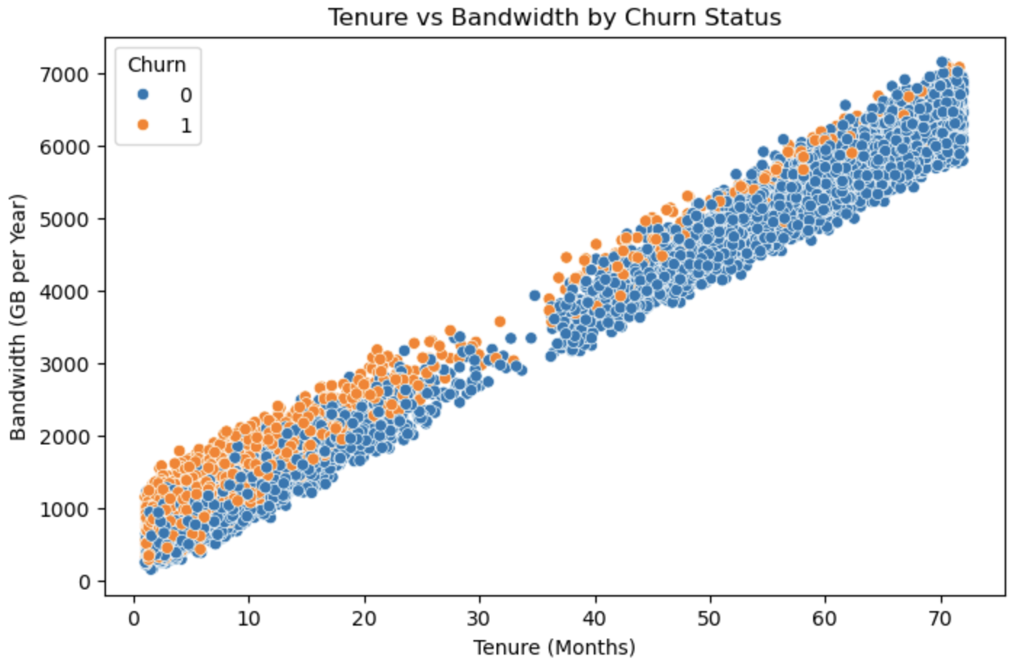
  - The goal of data transformation was to prepare the independent variables for
logistic regression by standardizing them and ensuring the dependent variable was correctly formatted for binary classification. The independent variables Tenure,
MonthlyCharge, and Bandwidth_GB_Year were standardized using z-score
normalization to ensure they were on the same scale. The dependent variable
Churn was already converted to a binary format (0 = No, 1 = Yes) during the data cleaning step. (Hackers Realm)
Steps for Data Transformation:
    - Standardized the independent variables using z-score scaling (mean = 0,
standard deviation = 1)
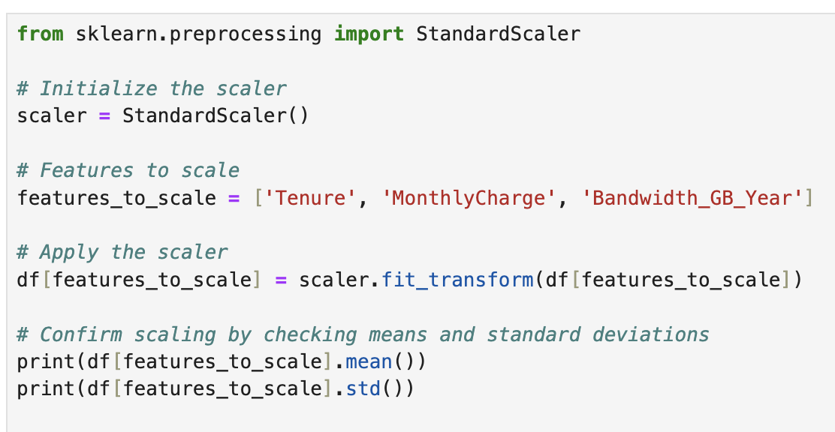
    - Confirmed that the Churn variable was binary and ready for modeling.
  - Cleaned CSV file attached to submission called:
“churn_prepared_for_logistic.csv”
- Initial vs. Reduced Logistic Regression Model
  - Initial Model
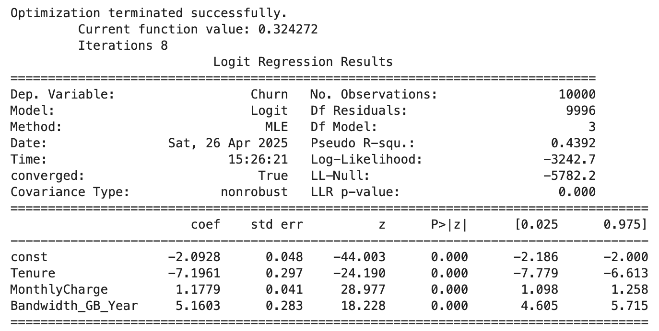
  - Feature selection was based on evaluating the p-values of each independent
variable in the initial logistic regression model. Since all predictors had p-values
less than 0.05, indicating they were statistically significant, no variables were
removed during the model reduction process.
  - Since all variables in the initial model were statistically significant, the reduced
logistic regression model includes the same predictors: Tenure, MonthlyCharge,
and Bandwidth_GB_Year. The reduced model output matches the initial model
output.
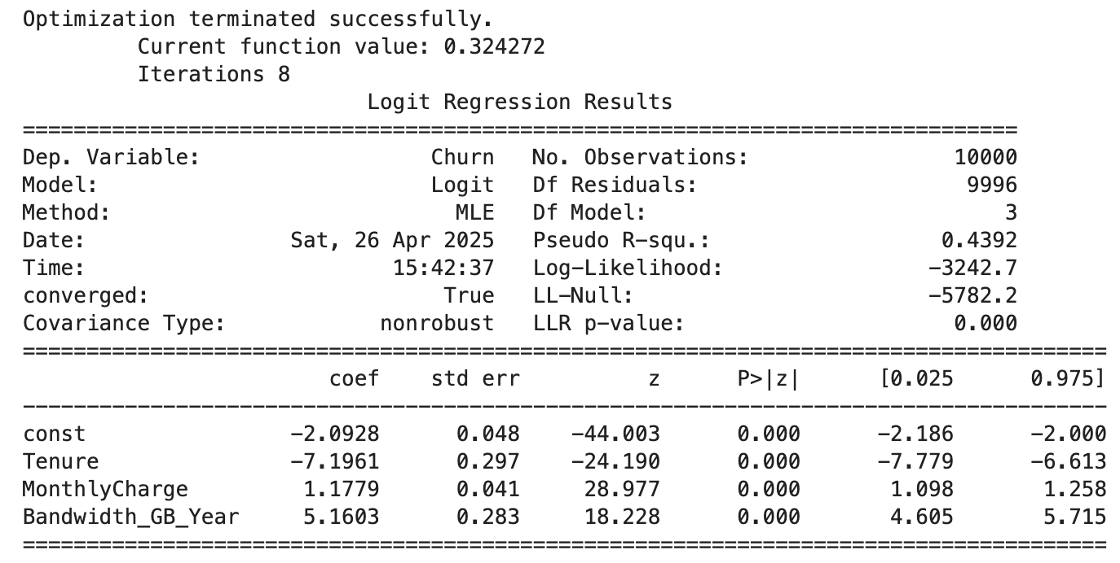
- Implications of Data
  - The initial and reduced logistic regression models were compared using accuracy as the evaluation metric. Since all independent variables were statistically
significant in the initial model, the reduced model included the same predictors.
As a result, the initial and reduced models are identical, and no difference in model performance was observed.
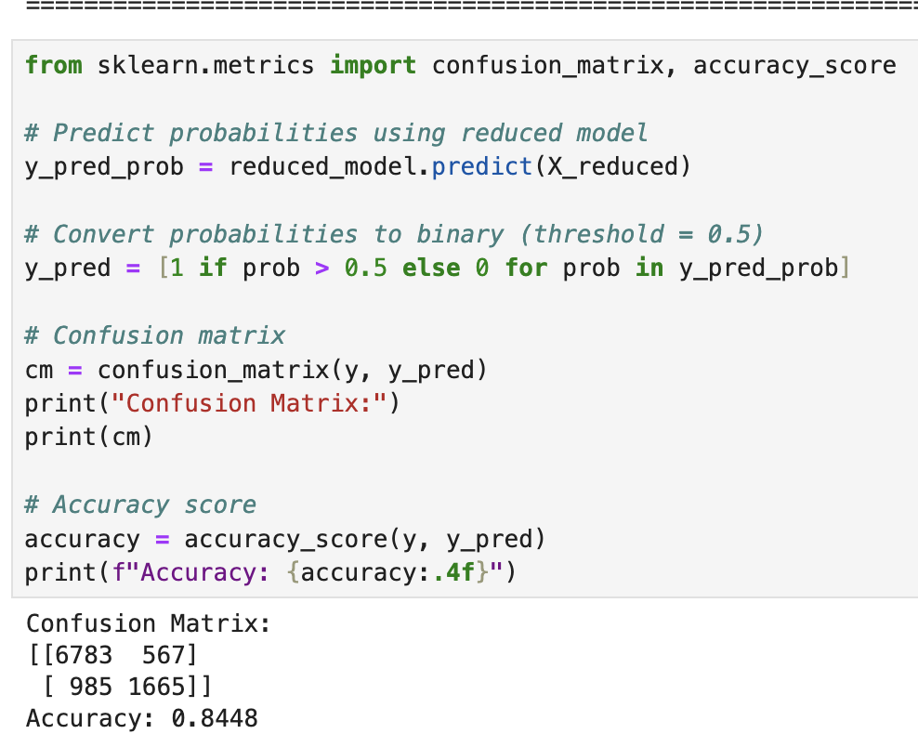
  - Confusion Matrix and Accuracy Calculation
  - Executable code is attached and is called: "D208.ipynb"
- Data Summary:
  - The reduced logistic regression model produced the following equation:

Log-odds (Churn) = -2.0928 - 7.1961 × Tenure + 1.1779 × MonthlyCharge + 5.1603 × Bandwidth_GB_Year

This means that for every one-unit increase in Tenure, the chances of a customer
churning go down, while increases in MonthlyCharge and Bandwidth_GB_Year
raise the chances of churn. All three predictors had p-values below 0.05, so they
are statistically significant. Practically, this model makes sense too because
customers who pay more or use more bandwidth might be less loyal, while
customers who stay longer are less likely to leave. One limitation is that the
model assumes a linear relationship and doesn’t capture every reason a customer might churn, like customer service experiences or outside competition.
  - Based on the results, I recommend the company focus on keeping customers who have high monthly charges and use a lot of bandwidth. These customers are at a
higher risk of leaving, so offering loyalty discounts, better customer service, or
custom plans could help keep them around. I would also suggest creating
incentives for new customers to stay longer because the model shows that the
longer someone stays, the less likely they are to churn.

- Panopto Link: https://wgu.hosted.panopto.com/Panopto/Pages/Sessions/List.aspx#folderID=%22c5e28fac-6ad0-4e87-b856-ac720189cb27%22
- Sources:
Assumptions of logistic regression. Statistics Solutions. (2024, December 31). https://www.statisticssolutions.com/free-resources/directory-of-statistical-analyses/assumptions-of-logistic-regression/#:~:text=First%2C%20binary%20logistic%20regression%20requires,10).
GeeksforGeeks. (2024, February 11). Univariate, bivariate and Multivariate Data and its analysis. https://www.geeksforgeeks.org/univariate-bivariate-and-multivariate-data-and-its-analysis/
Hackers Realm. (2023, November 11). Standardize data using Z-score/standard scalar: Python. https://www.hackersrealm.net/post/standardize-data-using-standard-scalar
Murel, J. (n.d.). Create a confusion matrix with Python. IBM developer. https://developer.ibm.com/tutorials/awb-confusion-matrix-python/

